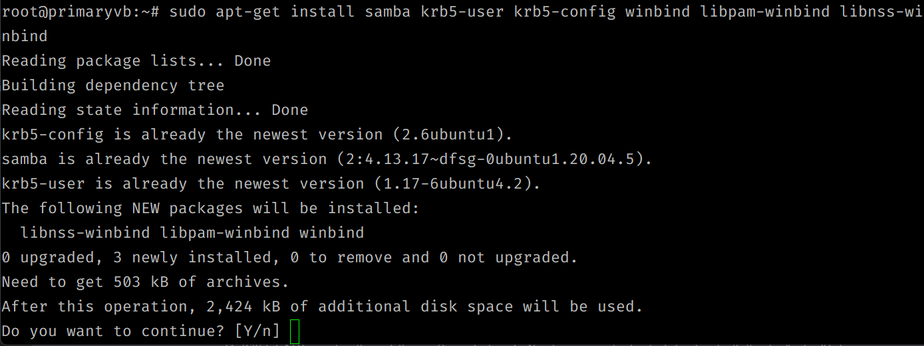

Samba, Kerberos, and Active Directory are all related to authentication and authorization in a networked environment, but they serve different purposes:

Samba: Samba is an open-source software suite that enables file and print sharing between Windows and Linux/Unix systems. It provides a way for Windows clients to access Linux/Unix file servers and printers, and vice versa. Samba can act as a domain controller, allowing it to authenticate users and manage their access to resources.

Kerberos: Kerberos is a network authentication protocol that uses a trusted third-party (the Kerberos server) to authenticate clients and servers. Kerberos provides a way to securely authenticate users and services over a network and to encrypt data between them.

Active Directory: Active Directory is Microsoft's implementation of a directory service for Windows-based networks. It provides a centralized database of users, computers, and other resources, and can manage their access to network resources. Active Directory uses the Kerberos protocol for authentication and encryption.

When using Samba with Active Directory, Samba can be configured to act as a domain member server, allowing it to authenticate users against the Active Directory database using Kerberos. This allows users to use their Active Directory credentials to access resources on the Samba server.

To set up Samba with Active Directory and Kerberos, the general steps are:

1. Join the Samba server to the Active Directory domain as a member server.
2. Configure Samba to use Kerberos for authentication and encryption.
3. Set up file and print sharing on the Samba server, and configure permissions for users and groups.
4. Test access to the Samba server using Active Directory credentials.

The specific steps and configuration details will depend on the versions of Samba, Kerberos, and Active Directory being used, as well as the specific network setup and security requirements.

Active Directory is a Microsoft product and is not natively available in Ubuntu. However, Ubuntu can be joined to an Active Directory domain and can use Active Directory services for authentication and authorization using Samba and Winbind.

Here are the steps to join Ubuntu to an Active Directory domain:

Install necessary packages: Install the Samba, Kerberos, and Winbind packages using your Ubuntu distribution's package manager.

Join Ubuntu machine to Active Directory: Use the **net ads join** command to join the Ubuntu machine to the Active Directory domain. Provide a valid domain administrator username and password to complete the process.

Configure Kerberos: Edit the Kerberos configuration file **/etc/krb5.conf** and update it with your Active Directory domain information. Ensure that the **default_realm** and **kdc** settings are correct.

Configure Samba: Edit the Samba configuration file **/etc/samba/smb.conf** and set the workgroup and realm to your Active Directory domain name. Update the security setting to use **ads**.

Start Samba services: Start the Samba and Winbind services using the **systemctl** command.

Configure permissions: Use the **getent passwd** command to ensure that the Active Directory users and groups are recognized. Then, set the required permissions for Samba users and groups in Active Directory.

Test the configuration: Use the **smbclient** command to test the Samba configuration by connecting to a share on the Ubuntu machine.

Once Ubuntu is joined to the Active Directory domain, users can log in using their Active Directory credentials and access resources on the Ubuntu machine that are available to their Active Directory user account.

Note: It's recommended to follow the official documentation and guidelines provided by the Samba and Kerberos teams while configuring the setup.